Cell Lab (50 points)

Directions: Write your answers below each question. There are 5 Parts to this lab. Upload and submit the assignment in the Cell Lab Assignment.

Part 1. Using a microscope (10 points)
You will need Adobe Flash for the microscope viewing:
Once downloaded for free, you may have to activate it. When you go to the microscope link, it will give you a prompt for a simple click to activate your Flash.
This animation will give you virtual hands-on practice adjusting and using a microscope: Practice using a microscope.
- Which slide did you view?
Flat glass slide
- Using the ocular housing, which power lens did you choose?
Resolving nosepiece
- What did you observe? (Describe the cell in your own words.)
I was able to see cell organelles such as the chloroplast. The cell looked enlarged.
- Change your lens power. What is your lens power now?
X40
b. What else did you have to adjust to view your specimen?
The nosepiece to see how each objective lens clicks to place.

Part 2. The Eukaryotic Cell – Plants & Animals (10 points)
View the Eukaryotic Cell

I. Choose Animal Cell (choose link below “Welcome to the Cells alive! Cell Module”)
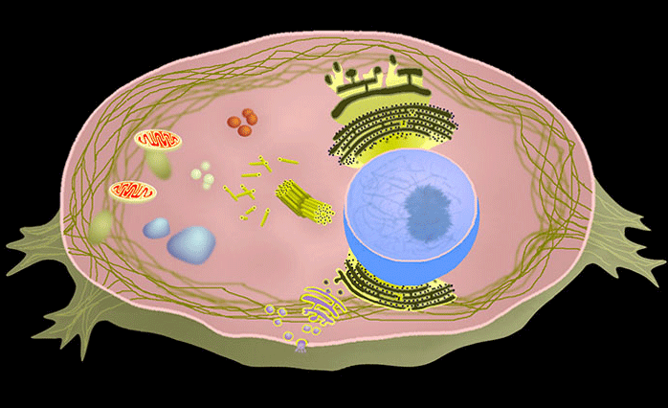
Click on each of the organelles to show where they are and their function.
- Which 2 organelles are not found in animal cells?
Chloroplast and vacuoles
- The cell’s DNA is within what organelle?
Nucleus
- Which organelle is known as the powerhouse or power center of the cell?
Mitochondria
b. It is called the powerhouse or power center of the cell because it produces what energy-carrying molecule?
Sugar is broken down to energy.

II. Choose Plant Cell (choose link below “Welcome to the Cells alive! Cell Module”)
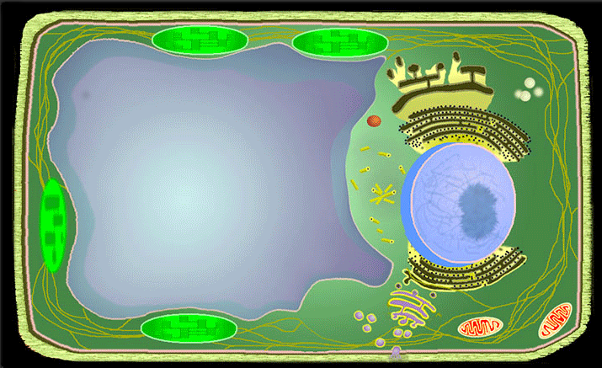
Click on each of the organelles to show where they are and their function.
- Name one organelle not found in plant cells?
Lysosome

Part 3. Cheek Smear Cells (6 points)
Look at this image of cheek cells under the microscope.
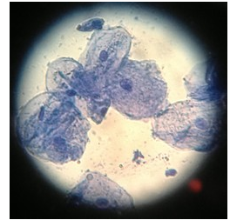
You are looking at several cells taken from the inside cheek of a student.
- The large dot within each cell is the largest organelle known as what?
Nucleus
- Is this a eukaryote or prokaryote cell?
Eukaryote cell
b. What do these cells have or not have that identifies them as eukaryote or prokaryote?
It has nuclear and organelles and it is enclosed by plasma membrane.

Part 4 Cellular Transport (12 points)
Refer to your chapter on 5.2 Passive Transport

I. Passive Transport
Let’s take a look at this animated activity on Diffusion

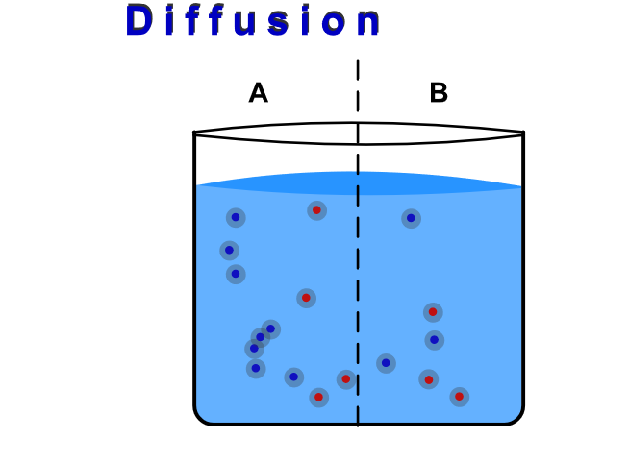
- What is meant by “the plasma membrane is selectively permeable?
It allows passage of ions and organic molecules and regulates the movement of substances in and out of cells.
2. The animation shows a concentration gradient. The definition of a concentration gradient is an area of high concentration adjacent to an area of low concentration
3. In the animation, which side has more molecules at the start?
Left side of the beaker.
4. The particles move back and forth until they reach no net movement or a lack of a concentration gradient, known as dynamic equilibrium.

5. “Molecules move constantly in a random manner, at a rate that depends on their mass, their environment, and the amount of thermal energy they possess, which in turn is a function of temperature.” (Section 5.2)

Watch the animation as the temperature is raised or lowered. Refer to Factors That Affect Diffusion – Temperature in your chapter section 5.2.

Explain why the molecules in the animation move faster as the temperature is raised?
When temperature is raised, the molecules and atoms vibrate faster. However, as atoms vibrate faster more space is created that enables it to move fast and collide.

II. Bulk Transport
Watch the 12-second Live video of Phagocytosis - a macrophage (type of white blood cell) engulfing a bacteria.
1. Refer to your reading to explain the purpose of the cellular function of phagocytosis.
Provides a defensive reaction against infection and invasion of the body by foreign substances.
Part 5: What is the fastest animal -- it may not be a cheetah! (7 points)
It is Cheetah because this animal is actually only slightly faster than the pronghorn antelope, and can reach speeds of up to 61 miles per hour.
Read and view short video on the one-celled Spirostomum
1. Now it’s your turn to find an interesting study, research, or already-established fact about cells. Write a brief summary in your own words. Use quotes where necessary. Give definition of scientific words. Give the source of your information.
You may use one of these sources to get ideas or search your own:
https://phys.org/
Seeking Single Cell Secrets
National Institute of Health – Stem Cells
Ideas to search: single cell study; single cell research; cell research

Your Response:
Cells are the most basic form of life; they make up every tissue and organ system in our bodies. Most of the cells are healthy, but this can change. They can become cancerous, get infected by viruses, undergo cycles and even become old.

End of Lab
Attribution:
This lesson was compiled for BIOL 160, Pierce College at JBLM. It is licensed under a Creative Commons Attribution 4.0 license and contains content from:

Eukaryotic Cells by Biology by OpenStax College is licensed under a Creative Commons License 4.0 International
Links within lesson from University of California and National Science Foundation
and University of Delaware
Image Attribution:
“Microscopes” by Phillip Martin for educational use
“Plant and Animal Cell” By Cells Alive is used for educational purposes.
“Cheek Smear” by Biology Corner is licensed under a Creative Commons License 4.0 International .
“Diffusion” from WISC-online of Wisconsin Technical Colleges is licensed under a Creative Commons License CC BY NC 4.0

